
YEAR 12 CHEMISTRY – 3BCHE

TEST 4

Organic Chemistry

Multiple Choice;

Questions 1-10 (1 mark each = 10 total)

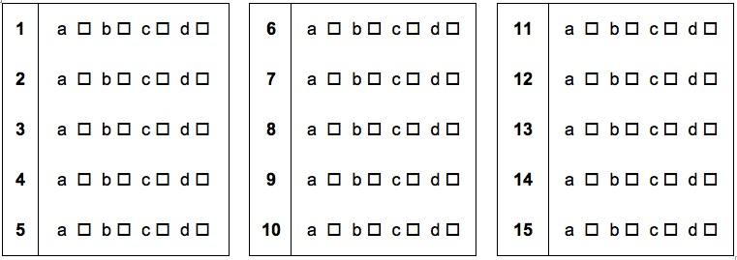

1. Compound D = CH₃CH₂COOCH₂CH₃ (1 mark)

Compound E = CH₃COCH₃ (1 mark)

2. Adding HCl will decrease the concentration of OH⁻ i.e. H⁺ + OH⁻→ H₂O (1 mark)
System favours forward to undo change (0.5 mark)
i.e. [sorbic acid] will increase (0.5 mark)

esters
3.
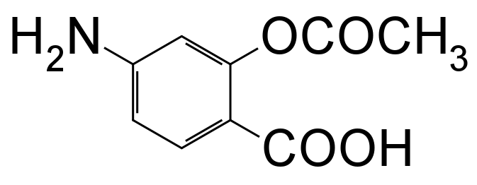
amine

carboxylic acid

(A) Any two (2) of the above (1 mark)
` 1
(B)

COO⁻ (1 mark)

(C) Pasercan be used as a buffer - amine group can act as a base to help remove H⁺ from solution
- carboxylic acid can act as an acid to help remove OH⁻ from solution.
(2 marks)

4. A)
methylethanoate  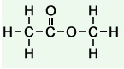 | ethylmethanoate  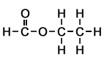

(2 marks – 1 mark per box)
B) pentyl propanoate

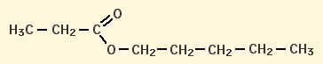
(1 mark)
5.
2-ethylpent-1-ene

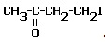

(2 marks – 1 per box)
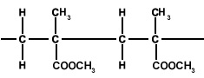
6.

(2 marks )
7.
(a) m(C) = (12.01/44.01) × 17.9 = 4.88 g (1 mark)
m(H) = (2.016/18.016) × 4.88 = 0.546 g (1 mark)
m(O) = 9.76 – 4.88 – 0.546 = 4.33 g (1 mark)
C H O
4.88 0.546 4.33
4.88/12.01 0.546/1.008 4.33/16.00
0.406 0.542 0.271
0.406/0.271 0.542/0.271 0.271/0.271
1.50 2.00 1.00 (1 mark)

Empirical formula C₃H₄O₂ (1 mark)

(b)
n(NaOH) = c × V = 0.487 × 0.0153 = 7.451 × 10⁻³mol (1 mark)
n(acid)in 50.0 mL = (1/2) × n(NaOH) = (1/2) × 7.451 × 10⁻³
= 3.725 × 10⁻³mol
n(acid)in 250.0 mL = (250/50) × 3.725 × 10⁻³ = 1.863 × 10-2 (1 mark)
M(acid) = m / n = 2.20 / 1.863 × 10⁻²= 118.1 g mol⁻¹ (1 mark)
(c) m (C) = 40.7/100 x 118 = 48 g/mol
i.e. n (C atoms) = 48/12.01 = 4 (1 mark)
Therefore formula of the dicarboxylic acid is C₄H₆O₄ or HOOC–CH₂-CH₂–COOH (1 mark)

Laboratory Test: Alcohols (20 marks)

Answer the following questions based on Experiments 25 and 26

1. (a) orange to green (1 mark)

(b) purple to pale pink (1 mark)

2. (a)

Reactant | Structural formula of product | IUPAC name of product
ethanol | 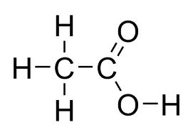  (1) | (1)  Ethanoic acid
butan-2-ol | 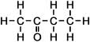  (1) | (1)  Butanone
2-methylpropan-2-ol | No product (1/2) | No product (1/2)

(b) 5CH₃CH₂CH₂CH₂OH + 4MnO₄⁻ + 12H⁺→ 5CH₃CH₂CH₂COOH + 4Mn²⁺ + 11H₂O (3 marks)

(c) permanganate solution changes from purple to pale pink (1 mark)

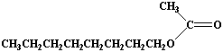
- (a) (1 mark)

- catalyse the reaction (1 mark)

- H₂O (1 mark)

(1 mark) | 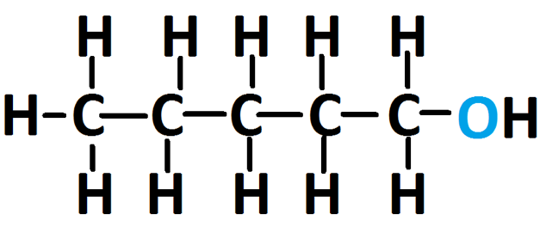  (1 mark)

- (a) H₂SO₄ is required to create an acidified KMnO₄ solution without which reduction of MnO₄⁻ can not occur. (1 mark)

- The rate of reaction is slow at room temperature (1 mark)

(c) i. H₂SO₄ is corrosive – handle with care ii. Alcohols are volatile & flammable – avoid open flame.
(2 marks)

